**DAILY ONLINE ACTIVITIES SUMMARY**

|  |  |  |  |  |  |  |  |
| --- | --- | --- | --- | --- | --- | --- | --- |
| **Date:** | **09-07-2020** | | | | **Name:** | **Veekshith Shetty** | |
| **Sem & Sec** | **8th sem B sec** | | | | **USN:** | **4AL16CS097** | |
| **Online Test Summary** | | | | | | | |
| **Subject** | | **-----** | | | | | |
| **Max. Marks** | | **----** | | **Score** | | **------** | |
| **Certification Course Summary** | | | | | | | |
| **Course** | **Amazon gamelift primer** | | | | | | |
| **Certificate Provider** | | | **AWS** | **Duration** | | | **6hrs** |
| **Coding Challenges** | | | | | | | |
| **Problem Statement-** : Function to print binary number using recursion | | | | | | | |
| **Status: completed** | | | | | | | |
| **Uploaded the report in Github** | | | | **yes** | | | |
| **If yes Repository name** | | | | **Veekshith-Shetty** | | | |
| **Uploaded the report in slack** | | | | **yes** | | | |

**Online Test Details**

**Certification Course Details:**

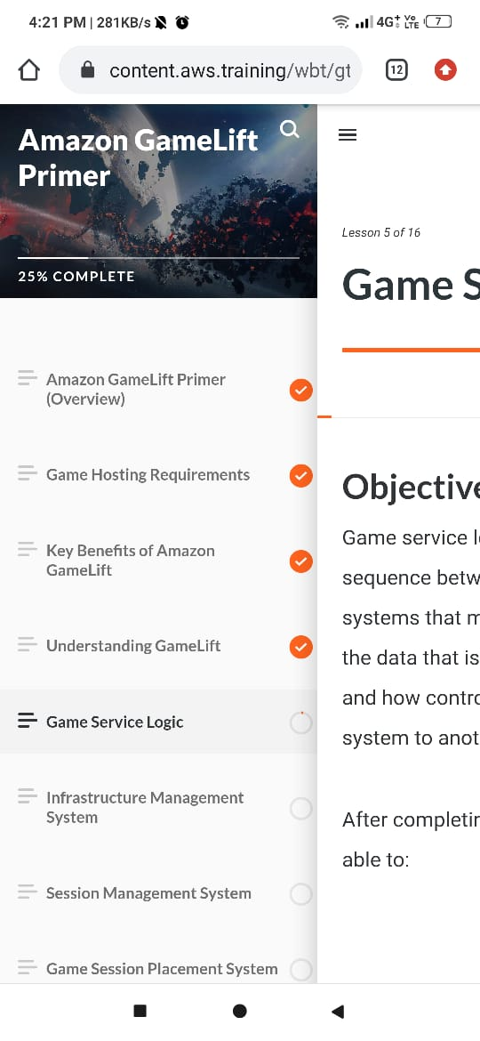

**Coding Challenges Details**  **def convertToBinary(n): if n > 1:**

**convertToBinary(n//2) print(n % 2,end = '') dec = 34 convertToBinary(dec) print()**